Experiment 21: Sharpening using Laplacian Mask Extended with Diagonal Neighbors
Software / Tools: Python · OpenCV (cv2) · NumPy

AIM
To sharpen an image using an extended 3x3 Laplacian mask that also includes the four diagonal neighbors (8-connected Laplacian).
ALGORITHM
1. Import OpenCV and NumPy.
2. Read the input image.
3. Define the extended Laplacian kernel [[1,1,1],[1,-8,1],[1,1,1]] which includes diagonal neighbors.
4. Apply cv2.filter2D() with this kernel.
5. Subtract the Laplacian response from the original image to sharpen it.
6. Clip values to [0,255] and convert to uint8.
7. Display and save the result.
PROGRAM (SOURCE CODE)
import cv2
import numpy as np

img = cv2.imread("image.jpg")

kernel = np.array([[1, 1, 1],
[1, -8, 1],
[1, 1, 1]])

laplacian = cv2.filter2D(img, cv2.CV_64F, kernel)
sharpened = np.clip(img.astype(np.float64) - laplacian, 0, 255).astype(np.uint8)

cv2.imshow("Sharpened (Diagonal Neighbors)", sharpened)
cv2.waitKey(0)
cv2.destroyAllWindows()

OUTPUT
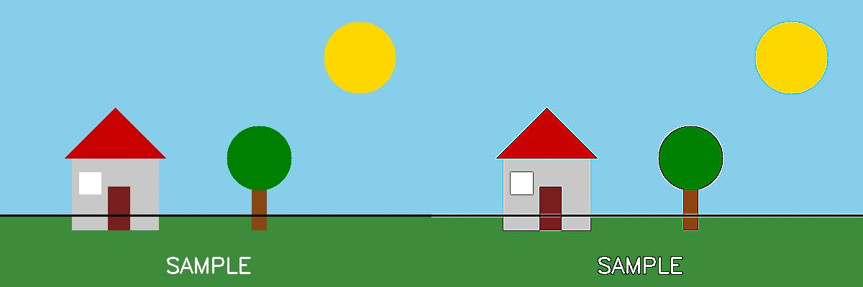
Fig. 21 — Output of Experiment 21: Sharpening using Laplacian Mask Extended with Diagonal Neighbors.
RESULT
Sharpen an image using an extended 3x3 Laplacian mask that also includes the four diagonal neighbors (8-connected Laplacian) — completed successfully, as demonstrated in the output shown above.

